**What is server?**

In Computing , a server is computer program or device that provides functionality for other programs or devices called “clients”

-This upper architecture is called client server model and a single computation is distributed across multiple process or devices

------------------------------------------------------------------------------------------------

**What is Clients?**

A client is a piece of computer hardware or software that accesses services that made available by server

**-----------------------------------------

**What is NIC**

(Network interface Controller/card)

1) (similarly like Network adapter, Lan Adapter or physical network interface)

2) Its hardware that connects computer to computer network

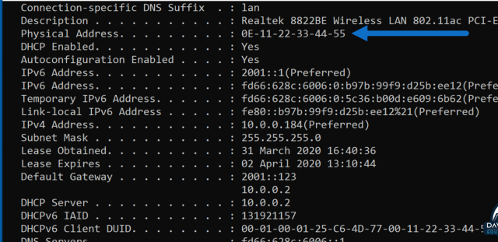----------------------------------------------------------------

**What is Mac(Media Access control ) Address?**

1. Its physical address in computer or devices
2. Its unique identifier Assigned to network interface Control(NIC) for use as network address in communication within network segment
3. This is commonly used mostly in IEEE 802 networking technologies, including ethernet, Wi-Fi, Bluetooth
4. MAC Address are like id cards for devices on network, assigned by manufacturer they’re called “burned-in address “because they’re usually fixed and can’t be easily changed but some of Mac address we can changed easily
5. Mac address is six group of two hexadecimal digits ,separated by (-),(,), or without separator

Eg.O0-B0-D0-63-C2-26

Check laptop MAC address(Cmd-C:\Users\tsayyad>ipconfig/all )

----------------------------------------------------------------------------------------------------------------

**What is modulation?**

Modulation is like changing the shape or strength of a regular signal to carry information.

E.g. like sound wave for example in older radio they used to change the frequency or the height of the waves to send music or speech

A device that does this modulation is called modulator.

-------------------------------------------------------------------------

What is demodulation?

Its opposite process of modulation where you take modulated signal and turn it back into its original form this is done by demodulator sometime its called detector

E.g. Modem which stands for modulator demodulator .its device can do both jobs :turning data into modulated signal for transmission ,and then turning the received modulated signal back into usable data .------------------------------------------------------------------------------------------------

**What is Topology ?**

Its physical arrangement of computer system/node which is connected to each other via communication medium is called topology

* Types- BUS, RING ,STAR,MESH, HYBRID,TREE

------------------------------------------------------------------

1. **Bus network topology**🡪

in bus topology one long cable acts as a single communication channel & all the devices are connected to this cable

**advantage-**

1. easy to add node or remove node
2. required only one cable and its less expensive
3. broadcast message to each devices
4. if any computer failure there will not affect on other devices

**Disadvantage-**

* cable fail network will fail
* because of broadcast we cant send private messages
* its takes to much time
* length is limited
* data transmitted only one direction

--------------------------------------------------------------------------------------------

**Ring Topology**🡪it’s called ring topology because it forms a ring in this topology each node is strongly connected with its adjacent node

Advantages- 1) it forms a strong network

2) each node can share data with each other

3) Transmission speed is high (distance less because of circle)

4) broadcast also

Disadvantages- 1) difficult to add new computer (cut wire then add)

2) when you send data to destination computer then data will be passed to other also

3) single point failure

4) it is very difficult to know which one machine is not working properly

5) we can’t send private msg

-----------------------------------------------------------------------------------------------------------------------------------------

**Star Topology🡪** in star topology all nodes relate to central device called hub .and sharing of data only possible through hub

Advantages- 1) It broadcast message

2) less expensive less cable

3) easily connect new node without any damage

4) if one node fail not affect on other

Disadvantages- 1) in star topology we must required a network devices like Hub, switch, router etc

2) directly not possible to transfer data mediator is needed like hub

3) if hub failed network totally failed

4) we can’t send private data

4) **MESH Topology**🡪 in this topology each and every nodes directly connected with each other, so we can directly send the data to the destination machine

Advantages-> 1) its good topology to send private messages because of interconnection

2) its provide point to point connection

3) if one network failed not affect on other

4) multiple data we can share and received

Disadvantages> 1) difficult to add new node

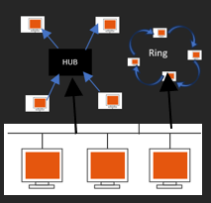 2) if particular machine fail so we unable to send and receive data from other

-----------------------------------------------------------------------------------------

**5.Hybrid Topology🡪**Combination of various topology is called hybrid

------------------------------------------------------------------------------------------------------------------------------------------

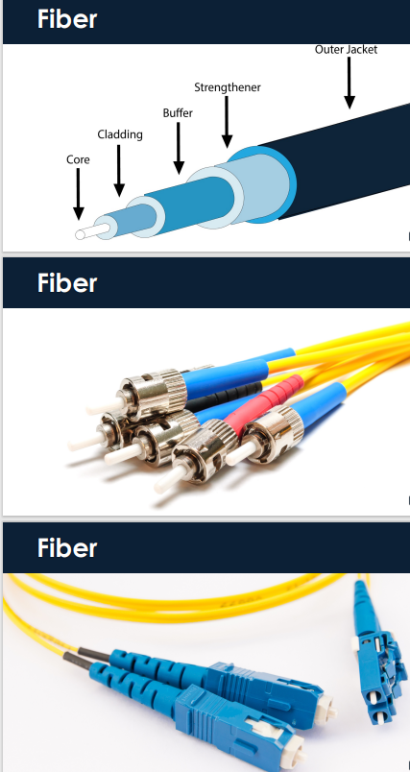**6.Tree Topology->** in this topology all the nodes are connected like branches of tree the combination of bus and star called tree

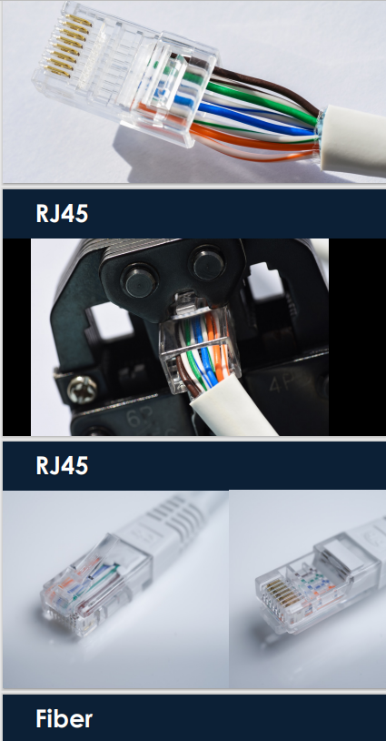

-----------------------------------------------------------------------------------------------------------------------------------------

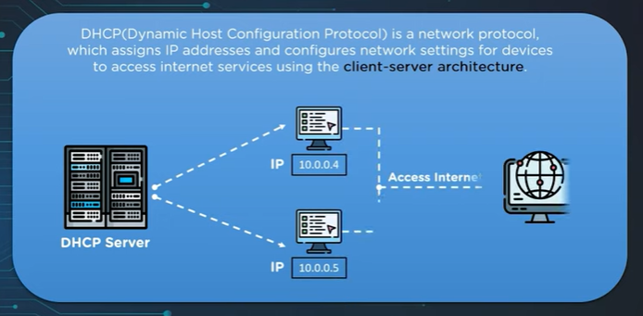**What is DHCP(Dynamic Host Configuration Protocol)?**

-its network management protocol used on internet protocol networks whereby a DHCP server dynamically assign IP address and other network configuration parameter to each device network so with help of IP they can connect with each other

-In absence of DHCP Server a computer or other devices on network need to be manually assigned an IP address.

-DHCP is not only computer router is also dhcp

**Working of DHCP🡪**

Server client model

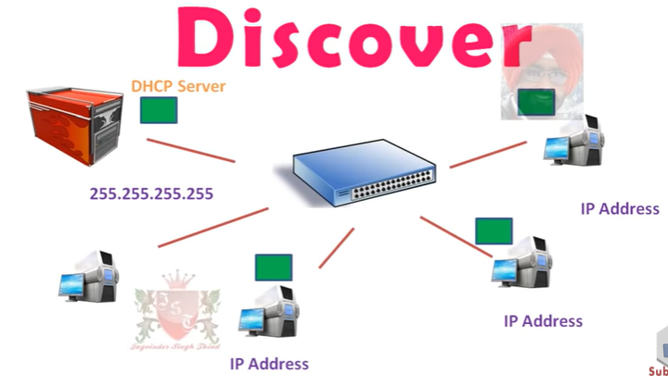UDP Port No .67 & 68 (67-DHCP server provide services ;68-client listen)

For working DORA(**D-**ISCOVER **O-**FFER **R-**EQUEST **A**-CKNOWLEDGEMENT)

1st steps -new computer discover the DHCP server and its broadcast message

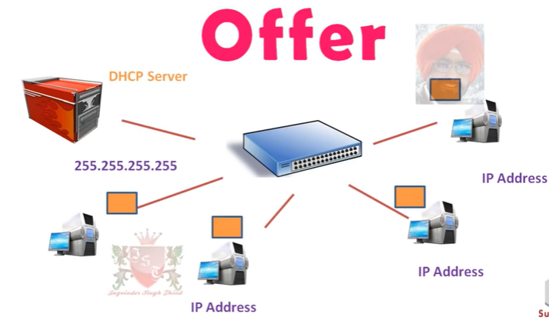

2nd steps -DHCP server sending msg(IP provide) against Discover msg its called offer, this message also broadcast but all computer already have IP Adress so ,actually in msg DHCP got mac address of Discover computer

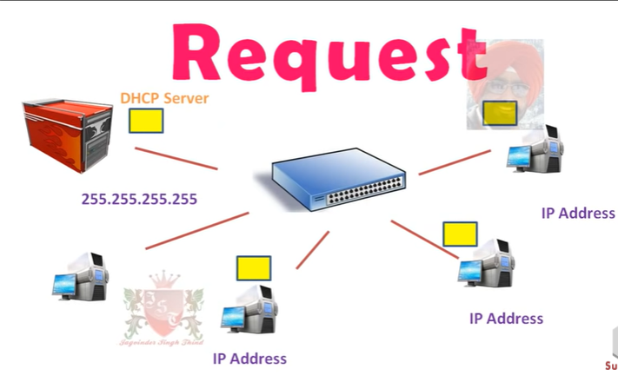3rd steps- when client got IP after they request again for DHCP server please allocate me IP (because of UDP port 67 they know this message for Server)

DHCP Send acknowledgement for client with the help of MAC Address

**----------------------------------------------------------------------------------------------------------------------------------------**

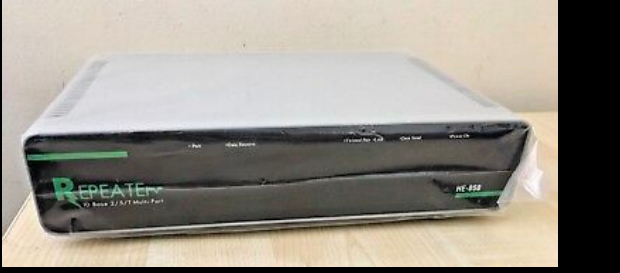**What is a Repeater?**

* In telecommunication repeater ,is an electronic device that receives a signal and transmit it
* Repeater is used to extend transmission so that signal can cover long distances

|  |  |
| --- | --- |
| Amplify | regenerate |
| Signal as it is transmit even impurities are there(Analog) | First filter out signal and then reconstruct and then transmit(Digital) |

* A diagram of a repeater

  Description automatically generatedRepeater can amplify and regenerate signal(digital +analog)…..difference between Amplify and regeneration
* We want connect more network so we want to so we added here repeater device
* A diagram of a repeater

  Description automatically generatedextend it for transmit signal

example-**Wi-Fi extender**

-------------------------------------------------------------------------

**What is a Hub?** (its real time meaning is that bike tire center it’s called hub)

A hub is a network device that can connect multiple Ethernet devices together. It operates at the physical layer (Layer 1) of the OSI model, functioning similarly to a repeater as it extends the network by providing multiple ports. (broadcast type work)

-the data is sent in bulk without the identification of its destination

Types of hubs:

1. Active - Regenerates or amplifies signals on the output side to maintain signal strength. Requires electricity.
2. Passive - Simply distributes signals to connected devices without modifying them.
3. 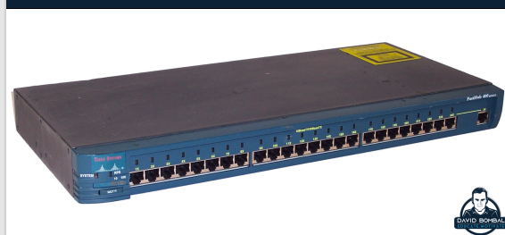Intelligent hubs - Offer additional features such as monitoring and management capabilities.

**What is a Switch?**

-Its networking hardware that connects devices like Wi-Fi, pc, server by using frame switching (device) to receive and forward data to destination device using mac address

-Its multiport network bridge

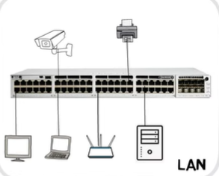

-All devices in broadcast domain which they will communicate each other

-Works at data link layer (layer 2) of OSI model

-switches that additionally process data at the network L3

• A network switch is a multiport network bridge that uses MAC addresses to forward data at the data link layer (layer 2) of the OSI or TCP/IP model. Some switches can also forward data at the network layer (layer 3) by additionally incorporating routing functionality. Such switches are commonly known as layer-3 switches or multilayer switches

**Working->**

+more intelligent than hub (because hub broadcast the message )

An ethernet switch create a separate collision domain for each switch port

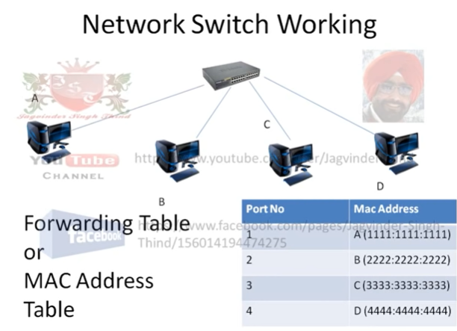

Eg.ABCD four switch ports A and B Can transfer data while same time C and D also do simultaneously and two conversation not interfere with one another.(collision domain)

1) full duplex communication(simultaneously work),

2) high speed data exchange

3) dedicated communication

**-Types Of Network switches?**

1) **Unmanaged**

PLUG AND PLAY without any configuration and its used in small networks or home setups

E.g. .Cisco 100 Series switch

2) **Managed**

-It can be Configured

-Greater Security

-More features

E.G Cisco Nexus 7k

* Its also divided in two layer
* Layer 2 and layer 3

**Layer2** only work with Mac address

* No need Ip address
* Do switching Only(transfer destination )
* Inter-VLAN communication (external router need for communicate)(connection between two pcs with different Vlan and Ip called vlan)

**Layer L3**->Multi-Layer switching

* Multilayer Switch
* Routing
* MAC add table
* Routing table
* Inter-reliant also

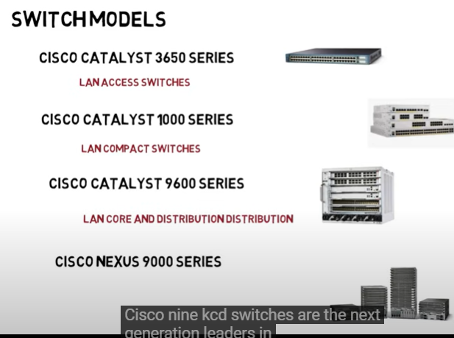

**---------------------------------------------------------------------------------------------------------------------**

**What is router?**

- forward data packets between computer network

-it operates layer 3 of the OSI model and make decision about best path for data to travel

-(traffic directing function on internet) it means router decides the best way for data packets to travel from one place to other on the internet they choses more fastest and reliable path to make sure your emails, web pages, and other online activities reach their destination smoothly

-router is connected to two or more data lines from different IP networks

-wan level communication

Types:

* Wired router
* Wireless router
* Edge router
* Virtual router
* ------------------------------------------------------------------------------------------------

**1) wired router->**

-wired router is box shaped device that connect directly to computer through cables or wired connection.

-it have multiple ethernet ports for connecting computers ,printers, and other devices to network

-this router commonly used in home ,small businesses

------------------------------------------------------------------------------

**2) Wireless router->**

-A wireless router is like a traffic manager for your homes internet

-it connects device like computer phones to the internet without cables it sends out signal called WIFI so you can use internet anywhere

**Wired Router**:

* Pros: Faster and more reliable connection, better security.
* Cons: Less mobility, requires cables for each device.

**Wireless Router**:

* Pros: Convenient, allows mobility, no cables needed.
* Cons: Slower and less reliable connection, potential security risks.

--------------------------------------------------------------------------------------------

**3)Virtual router->**

Its router that exist as software not hardware it runs on VM or in the cloud ,providing routing function without needing physical equipment

---------------------------------------------------------------------------------------------

4) **Edge router**

managing traffic going in and out. It's used to connect networks to the internet or other networks and often has strong security features.

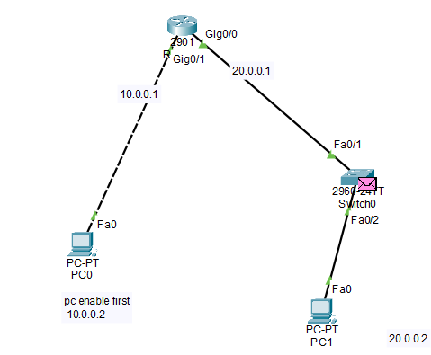Router Configuration->

Steps to config->

-Router>enable

-Router# configure t

-Router(config)#hostname R1

-R1(config)#interface gigabitEthernet 0/1

- R1(config-if)#ip address 10.0.01 255.0.0.0

-R1(config-if)#no shutdown

**------------------------------------------------------------------------------------------------------------------------------**

**What is a LAN and WAN?**

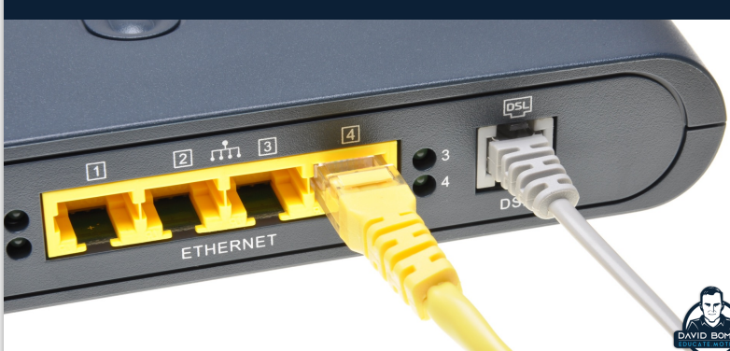**Lan->**

LAN is a computer Network that interconnects computer within limited Area such as residence, school, university campus or office

Ethernet and Wi-Fi are the two most common technologies in use for local area networks.

WAN->wide area network is telecommunication network that extends over large geographical area for the primary purpose of computer networking

-spanning regions, countries ,or even the world

**What is a Firewall?**

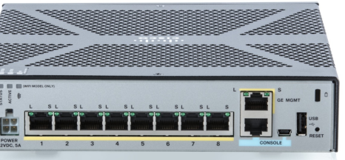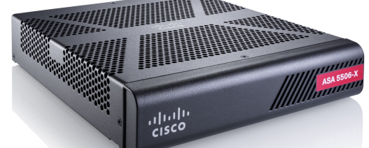

**Firewall is a network security system that monitors and controls incoming and outgoing network traffic based on predetermined security rules**

-firewall typically establishes barrier between a trusted internal network and untrusted external network such as the internet

-firewall categorized as either

**1)network firewalls**-> Filter Traffic between two or more networks and run on network hardware called n/w filter

**2) host based firewall**-> Host based firewall run on host computers and & control network traffic in and out of those machines

**-------------------------------------------------------------------------------------------------------------------------------**

**1. What is the OSI model?**

**Answer: The OSI model is a 7-layer framework that standardizes network communication.  
Example: When you send an email, the data travels from the Application Layer (Layer 7) down to the Physical Layer (Layer 1), then back up at the receiving end.**

**2. What is the difference between TCP and UDP?**

**Answer: TCP is connection-oriented and reliable; UDP is connectionless and faster.  
Example: TCP is used in web browsing (HTTP), while UDP is used in video streaming (Netflix).**

**3. What is a VLAN and why is it used?**

**Answer: VLANs logically separate networks to improve security and reduce traffic.  
Example: A company uses VLANs to separate its finance and HR departments’ network traffic.**

**4. Explain the difference between a hub, switch, and router.**

**Answer: A hub broadcasts data, a switch sends data to specific devices, and a router directs data between networks.  
Example: A router connects your home Wi-Fi to the internet, while a switch connects devices like laptops and printers.**

**5. What is subnetting?**

**Answer: Subnetting divides a network into smaller, efficient sub-networks.  
Example: A company with IP 192.168.1.0/24 splits it into subnets for different departments (e.g., 192.168.1.0/26 for IT).**

**6. What is NAT (Network Address Translation)?**

**Answer: NAT allows private IP addresses to communicate with external networks using a single public IP.  
Example: Your home router uses NAT to let multiple devices (phone, laptop) share one public IP.**

**7. Explain the function of ARP (Address Resolution Protocol).**

**Answer: ARP maps an IP address to a MAC address.  
Example: When your computer sends data to a printer on the same network, ARP finds the printer’s MAC address.**

**8. What are the different types of routing protocols?**

**Answer: Distance vector uses hop count, link state uses bandwidth, and hybrid combines both.  
Example: RIP (distance vector) and OSPF (link state) are common protocols used in businesses.**

**9. What is the purpose of the Spanning Tree Protocol (STP)?**

**Answer: STP prevents loops in networks with redundant links.  
Example: In a company with multiple switches, STP ensures no looping paths occur, keeping the network stable.**

**10. What is the purpose of DHCP?**

**Answer: DHCP automatically assigns IP addresses to devices.  
Example: When you connect to Wi-Fi, DHCP assigns your phone an IP address automatically.**

**11. What are the types of ACLs?**

**Answer: Standard ACLs filter by source IP; extended ACLs filter by source, destination, and protocols.  
Example: A company uses a standard ACL to block access to its server from certain IP ranges.**

**12. What is the difference between static and dynamic routing?**

**Answer: Static routing is manually set, while dynamic routing adjusts automatically.  
Example: Static routes are common in small office networks, while dynamic routing (e.g., OSPF) is used in larger enterprise networks.**

**13. What is a trunk port?**

**Answer: A trunk port carries traffic for multiple VLANs over one link.  
Example: A switch’s trunk port carries traffic for both the HR VLAN and Finance VLAN on a single cable.**

**14. What are collision and broadcast domains?**

**Answer: A collision domain is where data collisions occur; a broadcast domain is where broadcasts reach.  
Example: A hub creates one large collision domain, while a switch separates them.**